The flow of the project from my side
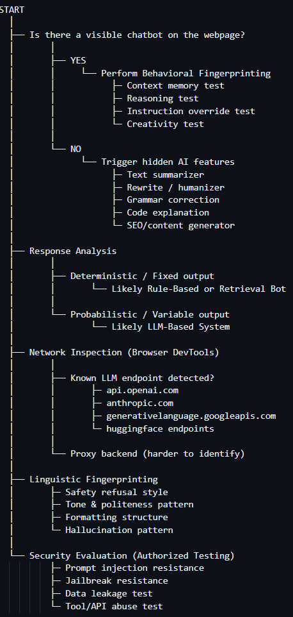

- Top 6 Reliable Client-Side Chatbot Detection Methods
# | Method | What You Do | Why It Works Across Platforms | Advantages | Limitations | Reliability
1 | Network Tab – XHR/Fetch Monitoring | Open DevTools → Network → Filter XHR/Fetch → Interact with site | Almost every chatbot sends messages via API calls | Direct evidence of chat communication | Proxy backend may hide provider | ⭐⭐⭐⭐⭐
2 | WebSocket Monitoring | Check “WS” tab for persistent connections | Many real-time chat systems use WebSockets | Strong indicator of live messaging | Some non-chat systems also use WS | ⭐⭐⭐⭐
3 | DOM Inspection (Elements Tab) | Search for keywords: chat, widget, assistant, messenger | Most chatbots inject a visible or hidden container | Works even if widget is hidden | Obfuscated code can make it harder | ⭐⭐⭐⭐
4 | JavaScript Source Search | Ctrl+Shift+F → Search for chat-related scripts | Chat systems load dedicated JS bundles | Detects third-party & custom bots | Harder if heavily bundled/minified | ⭐⭐⭐⭐
5 | Third-Party Script & Domain Detection | Check Network/Sources for known chat services | Many websites use SaaS chatbot providers | Fast identification of platform-based bots | Doesn’t confirm AI vs human | ⭐⭐⭐
6 | Conditional Trigger Testing (Interaction based) | Scroll, wait, click Help/Support/Login | Bots often load conditionally | Detects hidden or lazy-loaded bots | Time & interaction required | ⭐⭐⭐

- What if there is no visible chatbot
In that case we will perform various test case so that we can verify n validate the presence of LLM even without having chatbot in frontend interface

- PHASE 1 — Feature Identification (Surface Recon)
Step | What To Do | What To Look For | Why It Matters | Strong LLM Indicator
1.1 | Scan UI | “Generate”, “Rewrite”, “Summarize”, “Improve” | AI-powered text transformation | Dynamic long-form output
1.2 | Check Upload Features | Resume upload, PDF summary, report analysis | Text-processing pipeline | Context-aware analysis
1.3 | Inspect Search Features | “AI explanation” of search results | Natural language reasoning | Multi-paragraph explanation
1.4 | Inspect Email/Reply Features | “Auto draft reply” | Context-sensitive drafting | Tone adaptation
1.5 | Check SEO/Content Tools | Blog generator, caption generator | Creative generation | Structured article output

PHASE 2 — Behavioral / Response Analysis

Step | Test Name | Procedure | Deterministic Sign | Probabilistic Sign
3.1 | Repetition Test | Same input 5 times | Identical output | Wording variation
3.2 | Synonym Perturbation | Slight rephrasing | Same template reused | Structure adapts
3.3 | Creativity Stress Test | Ask for poem/story | Fallback message | Original creative output
3.4 | Structure Variation Test | Ask for bullet list repeatedly | Same bullets | Bullet order/phrasing changes
3.5 | Hallucination Test | Ask about fake event | “No data available” | Confident fabrication
3.6 | Logical Depth Test | Multi-step reasoning prompt | Simple template logic | Step-by-step reasoning

- PHASE 3 — Linguistic Fingerprinting
Dimension | Deterministic Bot | LLM-Based System | Indicator Strength
Safety Refusal | Generic block | Ethical reasoning explanation | High
Tone | Robotic | Adaptive & conversational | Medium
Formatting | Static | Structured headings & bullets | High
Vocabulary Range | Limited | Rich lexical diversity | High
Hallucination | Rare | Possible fabrication | Very High
Logical Flow | Fragmented | Smooth transitions | High

- PHASE 4 — Latency & Processing Behavior
Step | What To Observe | Deterministic | LLM-Like
5.1 | First-token delay | Instant output | Small delay before text
5.2 | Streaming | Full text appears instantly | Gradual streaming
5.3 | Length vs Time | Same response time | Longer text = longer processing
5.4 | CPU-like pause | None | Slight generation delay

- PHASE 5 — Confidence Scoring Model
Indicator | Points
AI-labeled feature detected | +1
Prompt/messages structure in payload | +2
Sampling parameters present | +2
Streaming response | +2
Output variation observed | +2
Creative generation successful | +1
Hallucination behavior | +1
Ethical structured refusal | +1

Final Interpretation
Total Score | Conclusion
7+ | Very Strong LLM Presence
5–6 | Likely LLM / Hybrid System
3–4 | Possible AI-assisted system
≤2 | Likely Rule-Based / Retrieval

Now the main thing to know whether the given response is Deterministic or Probabilistic
“Is the chatbot response deterministic (rule/retrieval based)
OR
probabilistic (LLM-based generative)”

Step | Test Name | Objective | Procedure | Example Prompt | If Output Is Identical | If Output Varies | Interpretation
1 | Repetition Test | Detect randomness in response | Send exact same prompt 5–10 times (clear session if needed) | Explain artificial intelligence in 3 sentences. | Same wording every time | Wording changes slightly each time | Identical → Likely deterministic. Variation → Probabilistic (LLM indicator).
2 | Synonym Perturbation Test | Check template reuse vs generative flexibility | Slightly rephrase same question multiple times | Explain AI in 3 sentences.Describe artificial intelligence briefly.Summarize AI concisely. | Same structure/template reused | Structure changes but meaning preserved | Template reuse → Retrieval/Rule-based. Structural variation → LLM.
3 | Creativity Stress Test | Test generative capability beyond database | Ask something unlikely in predefined database | Write a short poem about a robot who hates Mondays. | Returns fallback / generic response / fails | Produces original creative content | Creative generation → Strong LLM indicator.
4 | Structure Variation Test | Detect sampling differences in formatting | Ask for structured output and repeat | Give 5 bullet points about space. | Same bullets, same wording | Bullet wording/order changes | Variation → Probabilistic sampling present.
5 | Temperature Sensitivity Observation | Identify lexical diversity patterns | Repeat informational query and compare wording | Explain quantum physics simply. | Exact same phrasing | Synonym shifts, sentence order changes | Lexical diversity = Sampling behavior (LLM).
6 | Latency Pattern Observation | Observe generation mechanism | Watch response timing & streaming behavior | Any long response prompt | Instant full response | First-token delay + gradual streaming | Streaming = Token-by-token generation (LLM trait).
7 | Failure Outside Dataset Test | Check database limitation | Ask niche or absurd question | Why would a banana make a bad lawyer? | Cannot answer / fallback message | Generates reasoning creatively | Reasoning ability → LLM indicator.
8 | Edge Case: Temp = 0 Check | Detect deterministic-looking LLM | Ask complex multi-step reasoning question | If all cats are robots and robots hate water, do cats hate water? Explain logically. | Simple template logic | Detailed step-by-step reasoning | Deep reasoning even if identical → Likely LLM with low temperature.
Quick Scoring Framework — Deterministic vs Probabilistic Detection

Result | Meaning
P ≥ 4 | Strong LLM indicator
D ≥ 4 | Likely rule-based or retrieval system
Mixed (3–3, 4–3 close split) | Possibly hybrid or LLM with low temperature
Strong reasoning but identical outputs | Likely LLM with temperature = 0

- Linguistic Fingerprinting

What is Linguistic Fingerprinting?
It analyzes:
- Writing style
- Refusal patterns
- Structure patterns
- Reasoning depth
- Error behavior
- Hallucination tendencies

Safety Refusal Style Analysis

Parameter | Deterministic / Rule-Based Bot | LLM-Based System | What It Indicates
Refusal Style | Generic block message | Ethical explanation with reasoning | LLMs embed policy reasoning
Emotional Framing | None | Polite, ethical tone | Trained safety alignment
Depth of Refusal | Short & rigid | Multi-sentence structured explanation | Generative reasoning present
Consistency | Same message every time | Slight phrasing variation | Probabilistic generation
Example Response | “This request is not allowed.” | “I can’t assist with that request because accessing someone’s account without permission is illegal.” | Ethical contextualization = LLM
- Tone & Politeness Pattern
Parameter | Deterministic Bot | LLM-Based System | What It Indicates
Tone | Robotic / flat | Adaptive & conversational | Context awareness
Politeness | Static | Context-sensitive | Emotional intelligence modelling
Vocabulary Range | Limited | Rich lexical diversity | Large training corpus
Context Awareness | Low | High | Conversational memory
Style Variation | None | Changes depending on query | Sampling behaviour

- Formatting Structure Analysis
Parameter | Deterministic Bot | LLM-Based System | What It Indicates
Bullet Points | Rare / fixed template | Naturally structured lists | Instruction-following ability
Headings | No | Often auto-generated | Organizational reasoning
Paragraph Flow | Disjointed | Logical transitions | Coherent text generation
Balanced Length | Uneven | Balanced explanation depth | Token prediction control
Adaptive Formatting | No | Yes | Instruction-based formatting capability

- Hallucination Pattern Analysis
Parameter | Deterministic Bot | LLM-Based System | What It Indicates
Response to Fake Facts | “No data available.” | Generates plausible but false explanation | Generative model trait
Confidence Level | Low | High confidence tone | Probabilistic prediction
Detail Fabrication | Rare | Structured invented details | Language pattern completion
Logical Structure | Minimal | Coherent fabricated reasoning | Learned narrative patterns
Risk Indicator | Low hallucination | Possible hallucination | Strong LLM presence

- Combined Linguistic Fingerprinting Summary
Dimension | Deterministic System | LLM-Based System | Strength of Indicator
Safety Refusal | Rigid block | Ethical reasoning | ⭐⭐⭐⭐
Tone | Static | Adaptive | ⭐⭐⭐
Formatting | Fixed | Structured & dynamic | ⭐⭐⭐⭐
Creativity | Limited | High | ⭐⭐⭐⭐⭐
Hallucination | Rare | Possible | ⭐⭐⭐⭐⭐
Multi-Step Reasoning | Template logic | Deep structured reasoning | ⭐⭐⭐⭐

